沉 默 的 婆 罗 浮 屠
The Silence of Borobudur

竹笛、 琵琶与民族管弦乐队
For Zhudi, Pipa and Chinese Orchestra

朱一清
Zhu Yiqing

00/000

沉 默 的 婆 罗 浮 屠
The Silence of Borobudur

竹笛、 琵琶与民族管弦乐队
For Zhudi, Pipa and Chinese Orchestra

朱一清
Zhu Yiqing

(2011, rev. 2014)

15’

沉默的婆罗浮屠
The Silence of Borobudur

Copyright © Singapore Chinese Orchestra Ltd. All rights reserved.

版权所有, 未经许可, 不得以任何形式印刷、复制、扫描或发行。
Unauthorised printing, reproduction, scanning or distribution is strictly prohibited
without the express permission of the copyright holder.

Printed in Singapore.

Singapore Chinese Orchestra Ltd.
Singapore Conference Hall,
7 Shenton Way,
Singapore 068810

传Biography
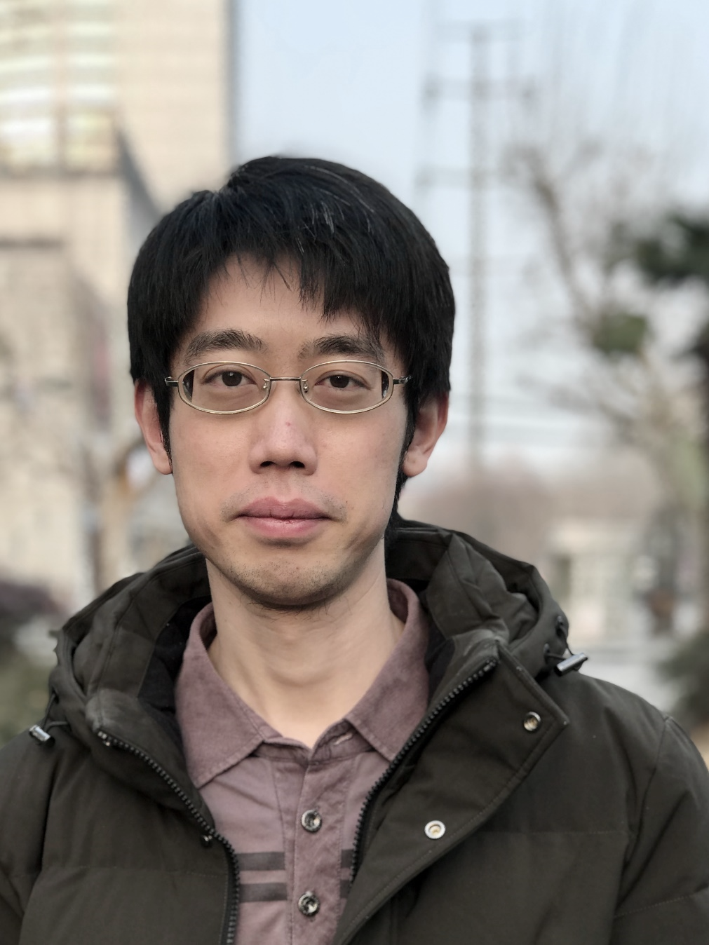
朱⼀清，作曲家，上海⾳乐学院作曲系教师，毕业于上海⾳乐学院和斯图加特⾳乐学院，师从吕⻩、叶国辉、 Niels Rosing-Schow、 Marco Stroppa。朱⼀清于2024年被授予著名的德国“恩斯特·冯·西门子作曲家奖”。他的作品 “DeepGrey” (为交响乐队) 获2021年瑞⼠ 巴塞尔作曲大赛 第⼀⼤奖； “Gigue” (为室内乐) 获2019年意⼤利 Dyce 作曲大赛 的唯⼀⼤奖；三⾸室内乐团与实时电⼦⾳乐作品 “Le ciel écrasé”, “Le visage déchiré”, “White Night” 获2019年奥地利 Impuls 作曲奖。 “The Silence of Borobudur” (⽵笛/琵琶和⺠族管弦乐队) 获2011年 新加坡华乐作曲大赛 第三名。除当代⾳乐之外，他的作品还涵盖了包括世界⾳乐、电⼦⾳乐、电脑⾳乐、流⾏⾳乐、爵⼠摇滚、电影⾳乐、多媒体⾳乐等诸多领域。

他的作品在世界各地被⼴泛上演，并与众多乐团建⽴委约与合作，包括 Ensemble Intercontemporain, Basel Sinfonietta, Singapore Chinese Orchestra, Ensemble Musikfabrik, Ensemble of Lucerne Festival Alumni, Klangforum Wien, Neue Vocalsolisten Stuttgart, Moscow Contemporary Music Ensemble, Mivos Quartet, Quatour Diotima, Divertimento Ensemble, Ensemble U:, Ensemble Cikada, Taller Sonoro, Ensemble xx. Jahrhundert Wien, Ensemble Soundstreams, Ensemble Suono Giallo, Han String Quartet, Ensemble Novel, Studio-C Ensemble, Copenhagen Piano Quartet, China-Asean Contemporary Orchestra, Ensemble Echtzeit, Telegraph Quartet 以及 上海交响乐团、上海爱乐乐团等等

Born in Dec.1989, Yiqing Zhu is a Chinese composer. He began composing in 2008 at Shanghai Conservatory of Music under the guidance of Prof. Huang Lv and Prof. Guohui Ye; after one year of Erasmus with Prof. Niels Rosing-Schow at The Royal Danish Academy of Music, he continued his study (Konzertexamen) at Stattliche Hochschule für Musik und Darstellende Kunst Stuttgart under the guidance of Prof. Marco Stroppa from 2016 to 2019. Currently, Zhu is the teacher of composition department at Shanghai Conservatory of Music.

As a recipient of the Ernst von Siemens Composers Prize 2024, Zhu’s works are widely played throughout Europe and Asia. His piece “DeepGrey”(for orchestra) won the 1st Prize of Basel Composition Competition 2021. He is also the winner of IMPULS Composition Competition 2019 in Graz, Dyce Composition Competition 2019 in Milan and the 3rd Prize winner of Singapore Chinese Orchestra competition 2011. Apart from contemporary music, he also works in the fields of Eastern traditional music, electronic music, computer music, jazz music, film music, world music as well as popular music.

His works were commissioned by various Music Festivals, such as MANIFESTE, ILSUONO contemporary Music Week, LUCERNE Festival, Shanghai New Music Week, Festival ARCHIPEL, DYCE Festival, IMPULS Festival, ACHT BRÜCKEN Festival etc. His music was performed by numerous soloists and, among others, Ensemble Intercontemporain, Basel Sinfonietta, Singapore Chinese Orchestra, Ensemble Musikfabrik, Ensemble of Lucerne Festival Alumni, Klangforum Wien, Neue Vocalsolisten Stuttgart, Moscow Contemporary Music Ensemble, Mivos Quartet, Quatour Diotima, Divertimento Ensemble, Ensemble U, Ensemble Cikada, Taller Sonoro, Ensemble xx. Jarhundert Wien, Ensemble Soundstreams, Ensemble Suono Giallo, Han String Quartet, Ensemble Novel, Studio-C Ensemble, Copenhagen Piano Quartet, China-Asean Contemporary Orchestra, Ensemble Echtzeit, Telegraph Quartet, Shanghai Symphony Orchestra, Shanghai Philharmonic Symphony Orchestra, etc

乐曲介绍Synopsis
公元919年赛伦德拉王朝被推翻后，婆罗浮屠就不再受到重视，任⻛⾬的剥蚀。公元1006年默拉⽐⽕⼭爆发，这座曾经的修道与朝拜的圣地，便被⽕⼭灰⻓久地掩埋在⿊暗、寂静的尘⼟之下。

The once mighty Mataram Kingdom of Java was declining by the start of the 10th century AD. As it declined, so did Borobudur; its importance to the people waned. In 1006 AD Mount Merapi erupted, burying the holy temple of monasticism and worship under a thick layer of volcanic ash for centuries to come, leaving the place to sit in perpetual silence.
编制Instrumentation
梆笛 I, II (Bangdi I, II)
曲笛 – C 调 (Qudi in C)
新笛 I, II (Xindi I, II)

高音笙 I, II (Gaoyin Sheng I, II)
中音笙 I, II (Zhongyin Sheng I, II)
低音笙 (Diyin Sheng)

高音唢呐 I*, II (Gaoyin Suona I*, II)
I* 兼奏高音管 (I* doub. Gaoyin Guan)
加键中音唢呐** (Jiajian Zhongyin Suona**)
**兼奏低音管 (doub. on Diyin Guan)

管 (兼: 高音，中音，低音) (Guan – High, Middle, Low)

扬琴 (Yangqin)
柳琴 I, II (Liuqin I, II)
琵琶 I-IV (Pipa I-IV)
中阮 I-IV (Zhongruan I-IV)
三弦 Sanxian
大阮 I, II (Daruan I, II)

古筝 (Guzheng)

竖琴 (Harp)

打击乐 I (Percussion I): (西方) 木鱼 (Woodblocks), 钟琴 (Glockenspiel), 云锣 (Yunluo), 小堂鼓 (Xiaotanggu), 排鼓 (Paigu), 中国木鱼 (Chinese Woodblock)
打击乐 II (Percussion II): 中国木鱼 (Chinese Woodblock), 颤音琴 (Vibraphone), 大钹 (Dabo), 排鼓 (Paigu), 军镲 (Cymbals), 通通鼓 (Tom-toms)
打击乐 III (Percussion III): 木琴 (Xylophone), 通通鼓 (Tom-toms), 乐鞭 (Whip), 康嘎鼓 (Congas)
打击乐 IV (Percussion IV): 编钟 (Bianzhong), 通通鼓 (Tom-toms), 马林巴 (Marimba), 军镲 (Cymbals)
打击乐 V (Percussion V): 铓锣 (Mangluo), 颤音琴 (Vibraphone), 编钟 (Bianzhong), 大军鼓 (Bass drum), 大锣 (Daluo)
打击乐 VI (Percussion VI): (中国)大鼓 (Dagu), Tubaphone, 小军鼓 (Snare Drum), (中国)大鼓 (Dagu), 编磬 (Bianqing)

竹笛独奏 (Zhudi solo)
琵琶独奏(Pipa solo)

高胡 (Gaohu)
二胡 (Erhu)
中胡 (Zhonghu)
大提琴 (Violoncello)
低音提琴 (Contrabass)

